# Feedback (Talking to Your Audience)

EMS 3M1

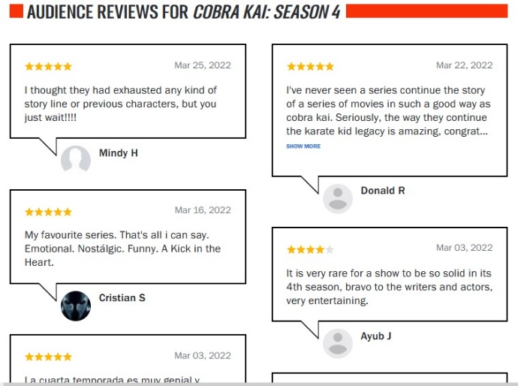Since forever, companies who have provided performances, products and services (food, movies, TV, shows, books and so on) have had ways to get feedback from their customers. These strategies have allowed customers/audiences to communicate with them and with one another, providing reviews, criticism and discussion. There are also third-party services such as Yelp! which allow people to comment on these companies and products in an honest way not regulated by the companies concerned.

## In Person

Write about various specific examples of companies you can name (minimum three) providing a means for customers to present themselves in person to raise concerns or show their appreciation for a performance, product or service. Talk about how it works, exactly (free samples, focus groups, fan clubs, conventions, customer service kiosks). Mention if it is only going to be used mainly for positive or negative communication. Use a mix of local and global businesses. Find examples from the past to compare to the ones you have encountered in the present.

## By Phone

Write about various specific examples of companies you can name (minimum three) providing a means for people to call by telephone to raise concerns or show their appreciation for a performance, product or service. Talk about how it works, exactly. (ex. telephone surveys) Mention if it is only going to be used mainly for positive or negative communication. Use a mix of local and global businesses. Find examples from the past to compare to the ones you have encountered in the present.

## On Paper

Write about various specific examples of companies you can name (minimum three) providing a means for people to mail them or fill out paper forms or cards to raise concerns or show their appreciation for a performance, product or service. Talk about how it works, exactly (ex. door to door opinion polls, newspaper movie reviews). Mention if it is only going to be used mainly for positive or negative communication. Use a mix of local and global businesses. Find examples from the past to compare to the ones you have encountered in the present.

## Online

Write about various specific examples of companies you can name (minimum three) providing a means for people to contribute their thoughts to raise concerns or show their appreciation for a performance, product or service. Talk about how it works, exactly. Mention if it is mainly going to be used mainly for positive or negative communication. Use a mix of local and global businesses. (Be sure to include online sites like Yelp! That are allowing people to review any number of people’s businesses, and not just Yelp! Itself.) Find examples from the past to compare to the ones you have encountered in the present.